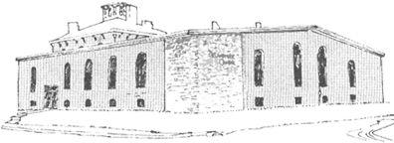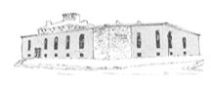

****

Pastor James Reynolds, Sr.

Asst. Pastor Stephen G. Reynolds, Sr.

1008 Congress St. Portland, ME 04102

Tel. (207) 774-8192

[www.**thedeliverancecenter**.com](http://www.thedeliverancecenter.com)

*From the Desk of Pastor Stephen Reynolds, Sr.*

To whom it may concern,

John Matero came to us, for help and we are now at this time helping him with food and shelter and he is seeking work at the Seaside Nursing Home at Back bay in Portland.

John is requesting a bus voucher to go to and from work.

Thank you so much

Sincerely,

Stephen G. Reynolds, Sr.

Assistant Pastor